E-FARMING

## (12bce0244,12bce0030,12bce0112)

**1) Problem statement:**

a) To build a website that will help farmers from Indian villagers to sell their products to different cities. It also creates awareness and provides different farming techniques through which they can be benefited.

b) This will include modification of present algorithms for searching and maintaining database and hence ensure a different prospective view.

**2) Objectives:**

The objectives are met by:

* Likitha Pachipulsu
* Creation of accounts/Registration by Farmers and wholesalers.
* To provide a portal for Farmers to sell their Products Online.
* Based on their preferences the language will be displayed accordingly.
* To provide a portal for Wholesalers to buy products online.
* Mahima Anantha
* Registered farmers can take the courses they require.
* To provide a portal where farmers can schedule classes.
* Online tutorials will be provided accordingly.
* Admin System will be maintained.
* Courses will be given according to their preferences.
* Likhita Kancharla
* Suggestion portal will be available to Farmers.
* Different Govt schemes helpful to farmers will be stated.
* Farming Techniques will be made available to the Farmers based on their requirements.(acc to the Season Crops will be stated)
* Apart from these techniques, other Farming equipment needs are also suggested (Pesticides, cattle etc).

**3) Feasibility Study:**

**a) Evaluation of the proportion of the proposed project:**

The potential of the proposed project will be able to create

**b)Justification that the project will be completed within the timeframe**

The project has well defined goals that are divided among the members of the group.Each task is scheduled accordingly and divided among the given number of days.

**c**)**Technical feasibility**

1)HTML/CSS

2)JavaScript

3)My SQL

4)PHP

**d)Operational feasibility**

This is highly operational because it meets the major problems that are faced by the farmers by providing a platform to sell their products and exposure to different farming techniques.

**4)Process model**

**Incremental model**

Incremental model is a one which combines the elements of waterfall model which are then applied in an iterative manner. It basically delivers a series of releases called increments which provide progressively more functionality for the client as each increment is delivered**.**

**Justification**

**a)** Generates working software quickly and early during the software life cycle.

**b)** This model is more flexible, less costly to change scope and requirements.

**c)** It is easier to test and debug during a smaller iteration.

**d)** In this model customer can respond to each built.

**e)** Easier to manage risk because risky pieces are identified and handled during each iteration.

**5**) **Deliverables**

a) Selling of farming products.

b) Purchasing of farming products that are sold by the farmers.

c) Techniques that can be used for farming activities that will help to provide better yield and profits for farming related products.

**Platforms**

a)HTML/CSS

b)Javascript

c)MY SQL

d)PHP

**6) Project Scheduling**

**Gantt chart**

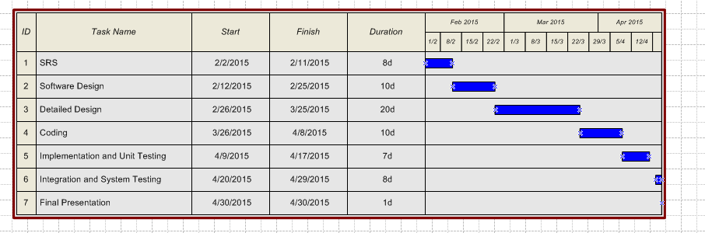

**Pert Chart**

